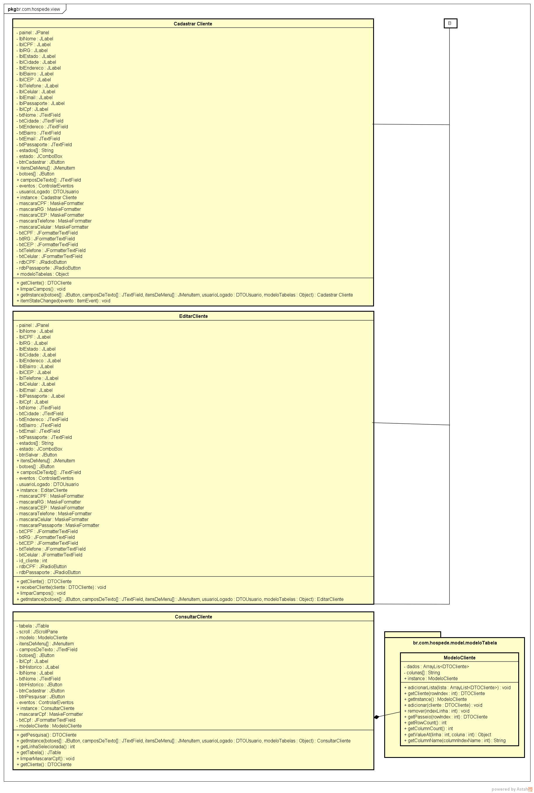

55

**Figura 7** – Diagrama de classes Camada view B